Unit I: Introduction to Data Modelling
1. Basic probability
- Discrete and continuous random variables:
  - Differentiate between Discrete and Continuous random variables with the help of an example. (2024) (2023)
Introduction: Random Variables
A random variable is a numerical representation of the outcome of a random experiment or phenomenon. It's a variable whose possible values are determined by chance. Random variables are broadly classified into two main types: Discrete and Continuous. The core difference lies in the nature of the values they can assume.

Primary Differences: Discrete vs. Continuous Variables
The following table outlines the key distinctions between discrete and continuous random variables:
Basis for Comparison | Discrete Random Variable | Continuous Random Variable
Meaning | Represents countable outcomes. The values are distinct and separate. | Represents measurable outcomes. It can take any value within a given range.
Possible Values | Can take a finite or countably infinite number of specific values. | Can take an infinite (uncountable) number of possible values within an interval.
Nature of Values | Values are typically integers or whole numbers. There are gaps between them (e.g., 1, 2, 3). | Can take any real number, including fractions and decimals, within its range (e.g., 2.5, 3.141).
Probability Model | Described by a Probability Mass Function (PMF), which gives the probability P(X = x) for each specific value 'x'. | Described by a Probability Density Function (PDF), f(x). The area under the curve gives the probability over a range.
Probability at a Point | The probability of a single value can be greater than zero, i.e., P(X = x) > 0. | The probability of any single, exact value is zero, i.e., P(X = x) = 0. We can only find P(a < X < b).
Graphical Representation | Represented by a bar chart or histogram where each bar corresponds to a specific value. | Represented by a smooth, continuous curve. The area under the curve represents probability.
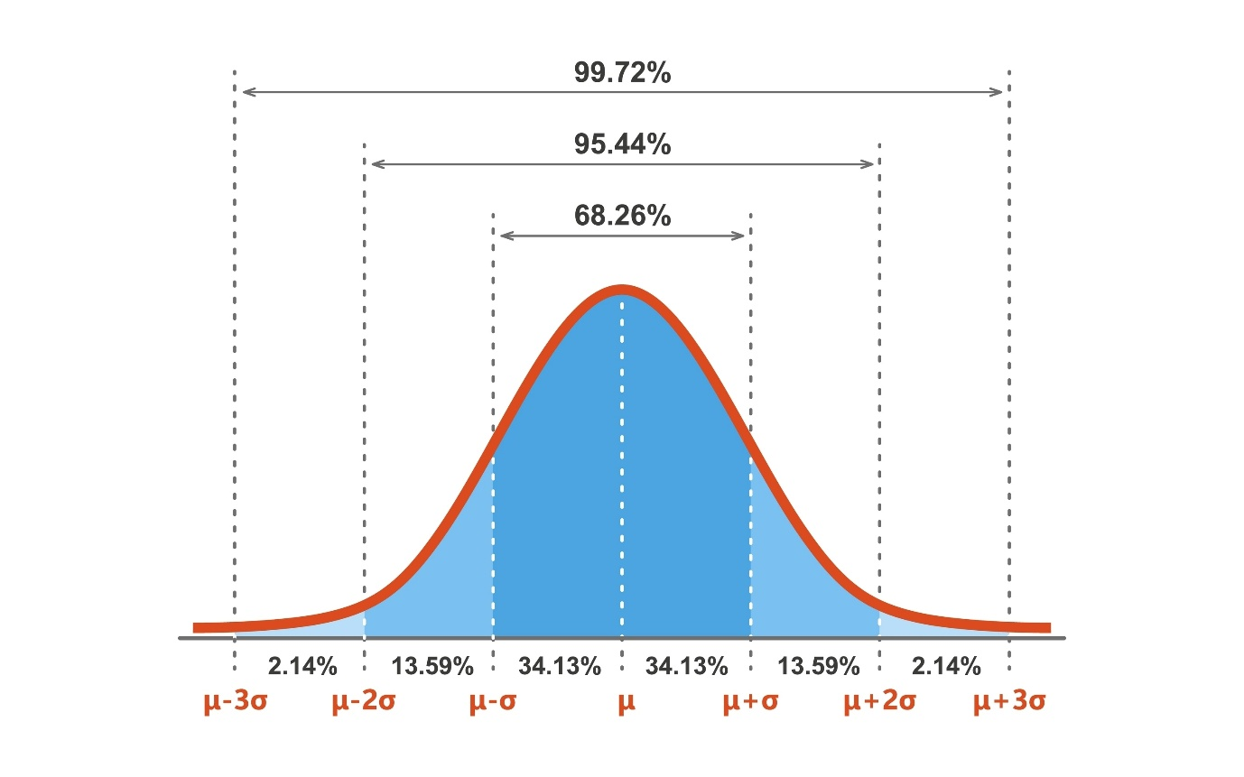
| | Core Idea | The variable is counted. | The variable is measured. |

Illustrative Examples Explained
To understand the difference in practice, consider the following detailed examples.
Example 1: Discrete Random Variable (Rolling a Die)
Imagine an experiment where you roll a standard six-sided die.
- Let the random variable X be the outcome of the roll.
- Countable Values: The possible values for X are {1, 2, 3, 4, 5, 6}. You can roll a 4 or a 5, but you cannot roll a 4.5. The set of outcomes is finite and countable.
- Probability (PMF): The probability of rolling any specific number is 1/6.
  - P(X = 1) = 1/6
  - P(X = 4) = 1/6
- This is a classic discrete variable because we are counting the dots on the face of the die.
Other Examples of Discrete Variables:
- The number of emails you receive in an hour (can be 0, 1, 2... but not 1.7).
- The number of defective items in a production batch.
- The number of students present in a class.

Example 2: Continuous Random Variable (Measuring Student Height)
Now, consider an experiment where you measure the exact height of a randomly selected student.
- Let the random variable Y be the height of the student in centimeters.
- Uncountable Values: The value of Y can be any real number within a realistic range, for instance, between 150 cm and 190 cm. A student's height could be 175 cm, 175.1 cm, 175.11 cm, or any value in between. The number of possible values is infinite and uncountable.
- Probability (PDF): The probability of a student having an exact height of, say, 175.1111... cm is practically zero because there are infinitely many possibilities. Instead, we calculate the probability over a range.
  - We ask: "What is the probability that a student's height is between 170 cm and 180 cm?" or P(170 < Y < 180).
  - This probability is found by calculating the area under the probability density curve between 170 and 180.
- This is a continuous variable because we are measuring the height, which can vary by infinitesimally small amounts.
Other Examples of Continuous Variables:
- The temperature of a room.
- The time it takes to complete a race.
- The weight of a package.

Conclusion
The fundamental distinction highlighted in this 2024 exam question is between
counting and measuring. If you can count the possible outcomes (even if they are infinite, like 1, 2, 3,...), the variable is discrete. If you must measure the outcome and it can take any value within a given interval, the variable is continuous.

- Independence:
  - Define Independent Variable and types of Independent Variables with Example. (2024)

- Covariance:
  - Explain Covariance and Central Limit Theorem. (2024)
Covariance
Covariance is a statistical measure that describes the direction of the linear relationship between two random variables. In simple terms, it tells us whether two variables tend to move together or in opposite directions.
Interpretation of Covariance Values:
- Positive Covariance (> 0): This indicates a direct relationship. When one variable increases, the other variable tends to increase as well.
  - Example: The relationship between temperature and ice cream sales. As the temperature rises, ice cream sales typically go up.
- Negative Covariance (< 0): This indicates an inverse relationship. When one variable increases, the other variable tends to decrease.
  - Example: The relationship between the number of hours spent studying and the number of mistakes made on an exam. More study time generally leads to fewer mistakes.
- Zero Covariance (≈ 0): This indicates that there is no linear relationship between the two variables.
  - Important Note: Zero covariance does not necessarily mean the variables are independent. They could have a strong non-linear relationship (e.g., a U-shape).
Formula:
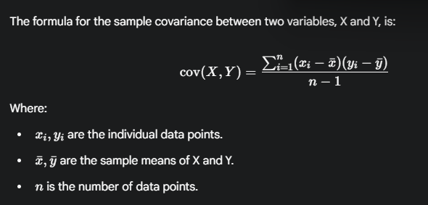
Limitation of Covariance:
The main drawback of covariance is that its magnitude is not standardized. A covariance of 200 is not necessarily twice as strong a relationship as a covariance of 100, because the value is dependent on the scale of the variables themselves. This makes it difficult to compare the strength of relationships across different pairs of variables. To overcome this, we use Correlation, which is the standardized version of covariance.

Central Limit Theorem (CLT)
The Central Limit Theorem is one of the most fundamental concepts in statistics. It describes the shape of the distribution of sample means.
Core Concept:
The theorem states that if you take sufficiently large random samples (usually n ≥ 30) from a population, the distribution of the sample means will be approximately normally distributed (a bell curve), regardless of the shape of the original population's distribution.
Analogy: The Biased Die
Imagine you have a weird, six-sided die that is heavily biased (e.g., it lands on '6' most of the time). The distribution of a single roll is not uniform at all.
- Sample: You roll this die 30 times and calculate the average of those rolls. You write this average down.
- Repeat: You repeat this entire process (rolling 30 times and averaging) thousands of times.
- Result: If you plot a histogram of all the averages you've collected, the Central Limit Theorem guarantees that this new distribution of averages will look like a perfect bell curve.
Why is the CLT so Important?
- It allows us to make inferences about a population's mean using the properties of the normal distribution, even if we have no idea what the population's distribution looks like.
- It is the statistical foundation for many common procedures like constructing confidence intervals and performing hypothesis tests (e.g., Z-tests and T-tests).
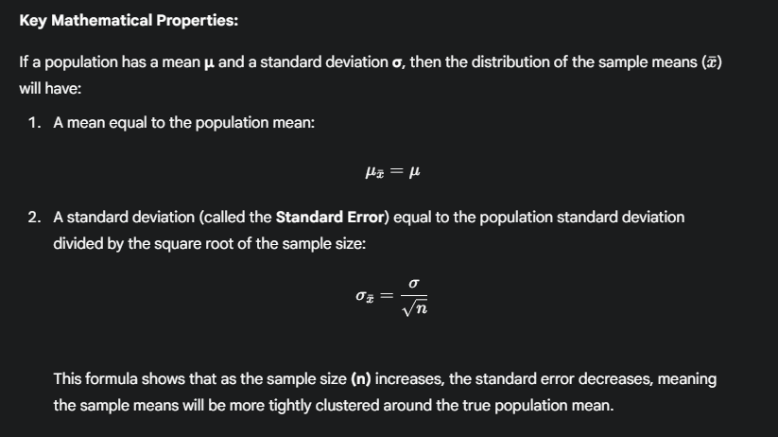

  - Explain in detail Positive, negative and zero covariance with appropriate graphs. (2023)
Covariance is a statistical measure that indicates the direction of the linear relationship between two variables. It helps us understand how two variables change together.

Positive Covariance
Positive covariance indicates a direct relationship between two variables. This means that as one variable increases, the other variable tends to increase as well. Similarly, as one decreases, the other tends to decrease. They move in the same direction.
- Example: The relationship between the number of hours a student studies and their final exam score. Generally, as the hours spent studying increase, the exam score tends to increase.
- Graphical Representation: A scatter plot of two variables with positive covariance will show a general upward trend from the bottom-left to the top-right. The data points cluster around a line with a positive slope.

Negative Covariance
Negative covariance indicates an inverse relationship between two variables. This means that as one variable increases, the other variable tends to decrease. They move in opposite directions.
- Example: The relationship between the outdoor temperature and sales of hot chocolate. As the temperature increases, the sales of hot chocolate tend to decrease.
- Graphical Representation: A scatter plot for negative covariance will show a general downward trend from the top-left to the bottom-right. The data points cluster around a line with a negative slope.

Zero (or Near-Zero) Covariance
Zero covariance indicates that there is no linear relationship between the two variables. An increase in one variable does not correspond to any predictable increase or decrease in the other variable in a linear fashion.
- Example: The relationship between a person's shoe size and their IQ score. There is no reason to believe that an increase in shoe size has any linear association with a change in IQ score.
- Important Note: Zero covariance only means there is no linear connection. The variables could still be related in a non-linear way (e.g., a U-shaped curve).
- Graphical Representation: A scatter plot for zero covariance will show no discernible pattern. The data points will appear to be scattered randomly with no clear upward or downward slope.

- Central limit theorem:
  - Explain Covariance and Central Limit Theorem. (2024)

- Chebyshev inequality:
  - Explain Chebyshev inequality with the help of an example. (2024) (2023)
Chebyshev's Inequality: The Concept
Chebyshev's Inequality is a fundamental principle in probability that provides a guaranteed lower bound on the percentage of data that must fall within a certain distance from the mean.
Its most powerful feature is its universality: it applies to any probability distribution, regardless of its shape (e.g., normal, skewed, or completely unknown), as long as the distribution has a defined mean and standard deviation. It gives us a "worst-case scenario" or a minimum guarantee.
The inequality states that for any random variable X with a mean μ and a standard deviation σ, the probability of X being within k standard deviations of the mean is at least 1 - 1/k².
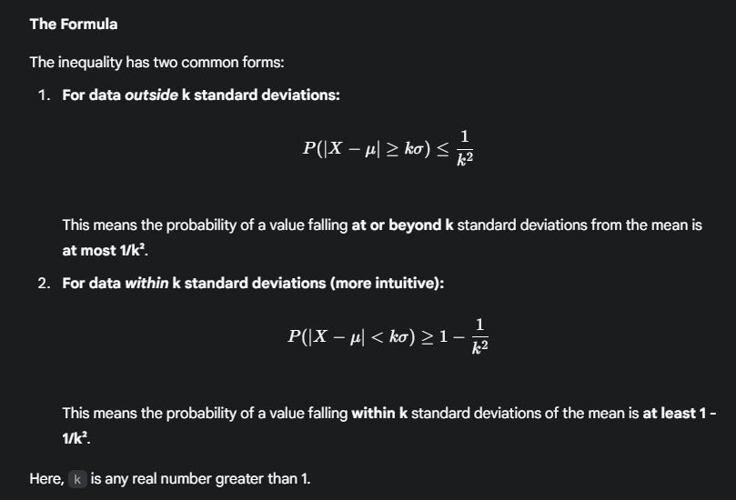
Step-by-Step Example
Let's use a practical example to illustrate how the inequality works.
Scenario: A factory manufactures batteries. The average lifespan of a battery is μ = 50 hours, with a standard deviation of σ = 5 hours. We do not know if the distribution of battery lifespans is normal.
Question: Using Chebyshev's Inequality, what is the minimum percentage of batteries that will have a lifespan between
40 and 60 hours?

Step 1: Determine the value of 'k'
First, we need to figure out how many standard deviations (k) away from the mean our interval (40 to 60 hours) is.
The formula for the interval is μ ± kσ.
- Upper bound: 60 = 50 + k * 5
  - 10 = k * 5
  - k = 2
- Lower bound: 40 = 50 - k * 5
  - -10 = -k * 5
  - k = 2
So, the interval represents all data points within k = 2 standard deviations of the mean.

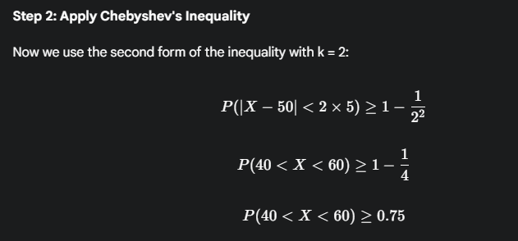

Step 3: State the Conclusion
The result ≥ 0.75 means that we can be certain that at least 75% of the batteries produced by the factory will have a lifespan between 40 and 60 hours.
This guarantee holds true no matter what the actual shape of the distribution is, which makes Chebyshev's Inequality a very robust and useful tool.

- Diverse continuous and discrete distributions:
  - Explain following discrete distributions: i) Geometric distribution ii) Binomial distribution. (2023)
A discrete probability distribution describes the probability of each possible outcome for a random variable that can only take on a finite or countably infinite number of values.

i) Binomial Distribution
The Binomial distribution is used to model the number of successes in a fixed number of independent trials. Think of it as answering the question: "If I try something 'n' times, what's the chance I succeed exactly 'k' times?"
Conditions for a Binomial Distribution
A scenario can be modeled by a Binomial distribution if it meets these four conditions (remember the acronym BINS):
- Binary: Each trial has only two possible outcomes: success or failure.
- Independent: The outcome of one trial does not affect the outcome of another.
- Number of Trials (n): The total number of trials is fixed in advance.
- Success Probability (p): The probability of success (p) is the same for every trial.
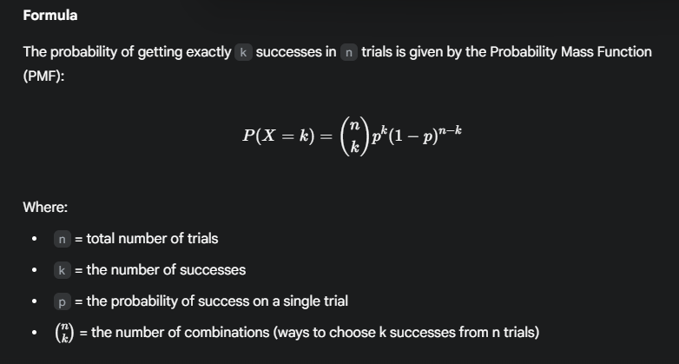Example
A student is taking a multiple-choice quiz with 10 questions. Each question has 4 options, only one of which is correct. The student guesses randomly on every question. What is the probability the student gets exactly 3 questions right?
- n = 10 (fixed number of trials)
- p = 0.25 (probability of success on one question)
- k = 3 (number of successes we want to find the probability for)
Using the formula:
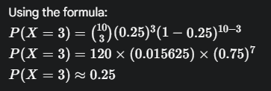
So, there is approximately a 25% chance the student gets exactly 3 questions correct.

ii) Geometric Distribution
The Geometric distribution is used to model the number of trials needed to achieve the first success. Think of it as answering the question: "How many times do I have to try until I finally succeed?"
Conditions for a Geometric Distribution
The conditions are very similar to Binomial, but the focus is different:
- Binary: Each trial results in either success or failure.
- Independent: Trials are independent.
- Success Probability (p): The probability of success (p) is constant for each trial.
- The random variable (k) is the number of trials up to and including the first success. The number of trials is not fixed.
Formula
The probability that the first success occurs on the k -th trial is given by the PMF:
P (X=k) =(1−p)^{k−1}p
This formula represents k-1 failures, each with probability (1-p), followed by one success with probability p.
Example
A basketball player has a 60% chance of making any given free throw. What is the probability that the first free throw she makes is on her 4th attempt?
- p = 0.60 (probability of success)
- k = 4 (the trial on which the first success occurs)
Using the formula:
P(X=4)=(1−0.60)⁴⁻¹×(0.60)
P(X=4)=(0.40)³×(0.60)
P(X=4)=0.064×0.60
P(X=4)=0.0384
So, there is a 3.84% chance that her first successful shot is on the 4th attempt.

2. Statistics, Parameter Estimation, and Fitting a Distribution
- Descriptive statistics:
  - Define Descriptive Statistics and Graphical Statistics. Explain different Estimation Methods. (2024) (2023)

Descriptive Statistics
Descriptive statistics is the branch of statistics concerned with summarizing, organizing, and presenting data in a clear and meaningful way. Its primary goal is to describe the main features of a dataset. It provides simple summaries about the sample and the measures. It doesn't involve making inferences or conclusions about a larger population beyond the data at hand. 📊
The main tools of descriptive statistics fall into two categories:
- Measures of Central Tendency: These describe the "center" or typical value of a dataset.
  - Mean: The average of all data points.
  - Median: The middle value when the data is sorted. It's less affected by outliers than the mean.
  - Mode: The most frequently occurring value in the dataset.
- Measures of Variability (or Dispersion): These describe the "spread" or how scattered the data is.
  - Range: The difference between the highest and lowest values.
  - Variance: The average of the squared differences from the Mean. It measures how far the data points are spread out.
  - Standard Deviation: The square root of the variance. It's a popular measure because it's expressed in the same units as the data itself.

Graphical Statistics
Graphical statistics is a component of descriptive statistics that uses visual representations like charts and plots to explore and present data. The goal is to identify patterns, trends, outliers, and relationships that might not be apparent from looking at raw numbers alone. A well-designed graph can convey complex information quickly and effectively. 📈
Common types of statistical graphs include:
- Histograms: Used to show the frequency distribution of a single continuous variable (e.g., the distribution of student scores on an exam).
- Bar Charts: Used to compare different categories of a categorical variable (e.g., comparing the number of students in different departments).
- Scatter Plots: Used to visualize the relationship between two continuous variables and to identify correlation (e.g., plotting student height vs. weight).
- Box Plots: Used to display the five-number summary of a dataset (minimum, first quartile, median, third quartile, and maximum) and to spot outliers.

Estimation Methods
In statistics, estimation is the process of using data from a sample to make an educated guess about the value of an unknown population parameter (like the true population mean). The two most common methods for this are the Method of Moments and Maximum Likelihood Estimation.

1. Method of Moments (MoM)
This is one of the oldest and most intuitive estimation methods.
- Core Idea: The principle is to equate the sample moments (statistics calculated from the sample data, like the sample mean) with the corresponding population moments (theoretical properties of the distribution). You then solve these equations for the unknown population parameters.
- Example: To estimate the population mean (μ), the Method of Moments simply uses the first sample moment, which is the sample mean (x̄). So, the MoM estimator for μ is x̄.
- Pros & Cons: It's generally simple to compute but may not always produce the "best" estimators. They can sometimes be biased or less efficient than other methods.

2. Maximum Likelihood Estimation (MLE)
This is the most widely used method of parameter estimation in modern statistics.
- Core Idea: MLE asks the question: "Given the sample data we have observed, what are the parameter values that would make observing this data most likely?" It finds the parameter values that maximize the Likelihood Function. The Likelihood Function calculates the probability of observing your specific sample, given a particular set of parameter values.
- Analogy: Imagine you flip a coin 10 times and get 7 heads. MLE would find the value for p (the coin's probability of landing heads) that makes this outcome most probable. Intuitively and mathematically, the answer is p = 0.7.
- Pros & Cons: MLE produces estimators with very desirable statistical properties (they are generally consistent, efficient, and unbiased in large samples). However, the process of maximizing the likelihood function can be more mathematically complex than the Method of Moments.

- Graphical statistics:
  - Define Descriptive Statistics and Graphical Statistics. Explain different Estimation Methods. (2024) (2023)

- Method of moments:
The Method of Moments (MoM) is one of the oldest and most intuitive techniques for estimating the parameters of a statistical model. The core idea is simple: assume that the sample moments (properties you calculate from your data) are good approximations of the true population moments (the theoretical properties of the distribution), and then solve for the parameters.

The Procedure
The method can be broken down into three straightforward steps:
- Identify Population Moments: First, express the theoretical moments of the distribution (like the mean or variance) as functions of the unknown parameters you want to estimate (e.g., μ, σ², λ).
- Calculate Sample Moments: Next, calculate the corresponding moments from your actual sample data. The first sample moment is simply the sample mean (x̄).
- Equate and Solve: Finally, set the population moments equal to the sample moments and solve the resulting system of equations for the unknown parameters.

Illustrative Example
Let's estimate the parameter λ (lambda) for a Poisson distribution. The Poisson distribution has only one parameter, λ, which represents its mean.
Scenario: You have a sample of data x₁, x₂, ..., xₙ that you believe comes from a Poisson distribution, but you don't know the value of λ.
- Step 1: Population Moment For a Poisson distribution, the first theoretical moment (the mean) is E[X] = λ.
- Step 2: Sample Moment The first sample moment is the sample mean, calculated from your data: x̄ = (Σxᵢ) / n.
- Step 3: Equate and Solve Set the population moment equal to the sample moment: E[X] = x̄
This gives us the simple result: λ = x̄
Conclusion: The Method of Moments estimator for the parameter λ of a Poisson distribution is just the sample mean of the data.

Pros and Cons
The Method of Moments is a valuable tool, but it's important to understand its strengths and weaknesses.
Pros
- Simple and Intuitive: Its logic is very straightforward and often easy to compute.
- Good Starting Point: It can provide good initial guesses for more complex estimation methods.
- Often Consistent: In many cases, as the sample size increases, the estimator converges to the true parameter value.
Cons
- Can be Inefficient: The estimators from MoM can have a larger variance than those from other methods like Maximum Likelihood Estimation (MLE), meaning they are less precise.
- May be Biased: MoM estimators are not always unbiased.
- Can Yield Invalid Estimates: Sometimes the method can produce estimates that are outside the allowable range for a parameter (e.g., a negative value for a parameter that must be positive).

- Maximum likelihood estimation:
  - Define and explain maximum likelihood estimation. (2023)
Definition
Maximum Likelihood Estimation (MLE) is a powerful statistical method for estimating the parameters of a model. The core idea is to find the parameter values that make the observed data most probable or most likely. In other words, it answers the question: "Given the data we have collected, what are the best possible parameter values that explain this data?"
The Detective Analogy 🕵️
Imagine a detective arriving at a crime scene.
- The Data: The evidence at the scene (fingerprints, clues, etc.) is the observed data.
- The Parameters: The potential suspects are the unknown parameters.
- The Goal: The detective evaluates each suspect's story. MLE is like the detective figuring out which suspect's story (which parameter value) makes the collected evidence seem the most plausible or likely. The suspect whose story best fits the evidence is our Maximum Likelihood Estimate.
How It Works: The Process
The method generally follows these steps:
- Define the Likelihood Function: First, you construct a "likelihood function." This function calculates the probability of observing your specific sample data for any given set of parameter values.
- Maximize the Likelihood: The goal is to find the specific parameter values that result in the highest possible value for the likelihood function. This is typically done using calculus to find the maximum of the function. In practice, it's often easier to maximize the log-likelihood (the natural log of the likelihood function), which simplifies the math.
- The Estimate: The parameter values that maximize the likelihood are called the Maximum Likelihood Estimates.
A Simple Example: The Biased Coin
This is the classic example to understand MLE.
Scenario: You suspect a coin is biased. You flip it 10 times and get the following result: 7 Heads and 3 Tails. You want to estimate the parameter p, the true probability of the coin landing on Heads.
The MLE Question: What value of p would make observing 7 heads and 3 tails the most likely outcome?
- Intuition: Your gut feeling would likely be that the best estimate for p is 7/10, or 0.7.
- MLE Confirmation: Maximum Likelihood Estimation formalizes this intuition. The likelihood of this outcome is based on the Binomial probability formula. MLE finds the value of p that maximizes this formula. Through calculus, it can be proven that the likelihood is maximized precisely when p = 0.7.
Conclusion: The Maximum Likelihood Estimate for the probability of getting a head (p) is 0.7.

3. Data Modeling Concepts
- General Concepts:
  - Explain Data Modelling Concepts with Example. (2024)
Data modeling is the process of creating a visual blueprint of an information system to define and organize data. It establishes the entities (the things we want to store data about), their attributes (their properties), and the relationships between them. Think of it as an architect's plan for a building, but for data.
To illustrate the main concepts, we'll use a single running example: an Employee Management System for a company. 🏢

Supertypes and Subtypes
This concept models an "is-a" relationship. A supertype is a generic entity, while a subtype is a specialized version that inherits the supertype's properties but also has its own unique attributes.
- Example: In our system, Employee is a supertype with general attributes like EmployeeID and Name. However, employees can be of different kinds.
  - Subtypes:
    - SalariedEmployee is an Employee but also has a unique attribute like AnnualSalary.
    - ContractEmployee is an Employee but also has unique attributes like HourlyRate and ContractEndDate.
This model is efficient because it avoids having empty, irrelevant fields (like HourlyRate for a salaried employee) in the main Employee table.

Hierarchical Data
This involves organizing data in a tree-like structure that represents a one-to-many relationship. Each "child" record has only one "parent."
- Example: The relationship between Departments and Employees.
  - One Department (the parent) can have many Employees (the children).
  - Each Employee belongs to only one Department.
This creates a clear hierarchy, such as the "Technology Department" having many employees under it.

Recursive Relationships
A recursive (or unary) relationship occurs when an entity has a relationship with itself. This is used when instances of the same entity type interact with each other.
- Example: The manager-subordinate structure within the Employee entity.
  - An Employee (in the role of a manager) manages other Employees.
  - This is modeled by adding a ManagerID attribute to the Employee table. The ManagerID for one employee would be the EmployeeID of another employee in the same table, creating a link within the entity.

Modeling Historical Data
This is the technique of tracking changes to data over time instead of just overwriting the old information. This is vital for auditing, reporting, and analyzing trends.
- Example: An employee's job title changes upon promotion. Instead of updating the JobTitle field and losing the old data, we create a separate JobHistory table.
  - When an employee moves from "Junior Developer" to "Senior Developer," a new record is added to JobHistory. The old record is preserved with an EndDate, and the new one begins.
JobHistory Table Example:
| EmployeeID | Title | StartDate | EndDate |
| :---------------- | :--------------------- | :--------------- | :-------------- |
| 101 | Junior Developer | 2023-06-01 | 2025-08-10 |
| 101 | Senior Developer | 2025-08-11 | (null) |
This provides a complete and accurate history of an employee's career path within the company.

- Understand and model subtypes and supertypes:
The supertype/subtype structure is a data modeling technique used to represent an "is-a" relationship, where a generic entity (the supertype) has specialized versions (the subtypes).
A supertype is a parent entity that contains all the common attributes shared by its subgroups. A subtype is a child entity that inherits all the attributes of its supertype but also includes its own unique attributes.
Example: A University System
Consider a university database that needs to store information about people. The generic entity is Person.
- Supertype: Person This entity holds the attributes common to everyone in the university.
  - PersonID
  - FirstName
  - LastName
  - DateOfBirth
However, a person can be a student or a professor, each with their own specific information.
- Subtypes: Student and Professor These entities are specialized versions of Person.
  - Student: A Student is a Person. It inherits all of Person's attributes and adds its own unique attributes like StudentID, Major, and GPA.
  - Professor: A Professor is a Person. It inherits all of Person's attributes and adds its own unique attributes like FacultyID, Department, and OfficeNumber.
Why Model This Way?
Using this structure provides several key benefits:
- Avoids Null Values: It prevents having a single, massive Person table with empty fields. For example, the GPA field would be empty (null) for every professor, and the OfficeNumber would be null for every student.
- Improves Data Integrity: It ensures that only relevant attributes are associated with an entity. A Student cannot have a FacultyID, and a Professor cannot have a GPA.
- Increases Clarity: The model becomes easier to understand because it more accurately reflects the real-world structure of the university's population.

- Understand and model hierarchical data:
Hierarchical data is data that is organized in a tree-like structure. The key feature is a parent-child relationship, where each "child" has exactly one "parent," but a "parent" can have many "children." This structure represents a one-to-many relationship and is common in real-world scenarios like company organizational charts, file systems, or product categories.
How to Model Hierarchical Data
In a relational database, you can model a hierarchy within a single table using a self-referencing foreign key. Here's how:
- Each record in the table has a unique primary key (e.g., CategoryID).
- The table also includes a foreign key column (e.g., ParentCategoryID) that refers back to its own primary key.
- For any given record, this "parent" column holds the ID of its parent record. The top-level records, or "roots" of the tree, will have a NULL value in this parent column.
Example: E-commerce Product Categories
Imagine an online store that needs to organize its products. 💻
The hierarchy might look like this:
- Electronics
  - Computers & Laptops
    - Laptops
    - Desktops
  - Smartphones & Accessories
    - Smartphones
    - Chargers
This structure can be modeled in a single Categories table:
CategoryID (PK) | CategoryName | ParentCategoryID (FK)
1 | Electronics | (null)
2 | Computers & Laptops | 1
3 | Smartphones & Accessories | 1
4 | Laptops | 2
5 | Desktops | 2
6 | Smartphones | 3
7 | Chargers | 3
Explanation:
- Electronics has a NULL ParentCategoryID, so it's a top-level (root) category.
- Computers & Laptops has a ParentCategoryID of 1, making it a child of Electronics.
- Laptops has a ParentCategoryID of 2, making it a child of Computers & Laptops.
This simple and elegant model allows you to represent a deep and complex hierarchy in a standard database table, making it easy to manage and query.

- Understand and model recursive relationships:
A recursive relationship, also known as a unary relationship, is a relationship where an entity is related to itself. This occurs when instances of the same entity type can interact with each other, often by playing different roles.
The most common way to model this in a database is by adding a foreign key to a table that refers back to the primary key of that same table.
Example: The Employee-Manager Hierarchy
The classic example of a recursive relationship is the organizational structure within a company. A manager is an employee, and the people they manage are also employees. 🧑‍💼
Scenario: We have an Employees table. To model the "manages" relationship, we can add a ManagerID column. This ManagerID will contain the EmployeeID of the employee's manager.
The Employees Table Model:
EmployeeID (PK) | Name | ManagerID (FK)
101 | Alice | (null)
102 | Bob | 101
103 | Charlie | 101
104 | David | 102
Explanation:
- Alice has a NULL ManagerID, indicating she is at the top of the hierarchy (e.g., the CEO).
- Bob's ManagerID is 101, which points back to Alice. This means Alice is Bob's manager.
- David's ManagerID is 102, which points back to Bob. This means Bob is David's manager.
This simple, self-referencing structure allows you to build out an entire organizational chart using just a single table. It's an efficient and powerful way to represent hierarchical or other self-referential structures.

- Understand and model historical data:
Modeling historical data is the practice of designing a database to keep a record of changes over time, rather than simply overwriting old information with new updates. The primary goal is to maintain a complete history of the data's evolution, which is crucial for auditing, reporting, and trend analysis. ⏳
Why Model Historical Data?
- Auditing & Compliance: To track who changed what data and when.
- Trend Analysis: To analyze how data, like sales figures or prices, has changed over months or years.
- Point-in-Time Reporting: To see what the data looked like on a specific date in the past.
How to Model Historical Data
A common and effective method is to create a separate history table. When a value changes in the main table, instead of updating it, the old record is "closed" and a new record is created to reflect the new state. This is typically managed using effective date columns.
The key attributes in a history table are:
- EffectiveDate or StartDate: The date/time the record became active.
- EndDate: The date/time the record was replaced by a new one. The currently active record will have a NULL or a far-future date in this column.
Example: Tracking Product Price Changes
Scenario: An online store needs to track the price of its products over time. Simply updating the Price column in the Products table would erase all history.
Solution: We create a PriceHistory table.
PriceHistory Table Model:
PriceHistoryID (PK) | ProductID (FK) | Price | EffectiveDate | EndDate
1 | 456 | 19.99 | 2024-01-20 | 2024-07-31
2 | 456 | 24.99 | 2024-08-01 | 2025-02-14
3 | 456 | 22.50 | 2025-02-15 | (null)
Explanation:
- This table shows the complete pricing journey for the product with ProductID 456.
- The product was priced at $19.99 until July 31, 2024.
- On August 1, 2024, the price changed to $24.99.
- The current price is $22.50, as indicated by the NULL EndDate, meaning this record has not been superseded.
This method provides a full, unalterable record of past states, which is invaluable for business intelligence and maintaining data integrity.

Unit II: Testing and Data Modeling
1. Random Numbers and Simulation
Monte Carlo Methods
Monte Carlo methods are a broad class of algorithms that use repeated random sampling to obtain numerical results. The core idea is to use randomness to solve problems that might be deterministic in principle but are otherwise difficult to solve. Think of it as repeatedly playing out a scenario with random inputs to estimate an average outcome.
A classic application, and a question from both the 2023 and 2024 exams, is estimating the value of Pi ( π ).

Calculating Pi (π) Using the Monte Carlo Method
This method uses the relationship between the area of a circle and the square that encloses it.
1. The Geometric Setup Imagine a square in the xy-plane with its corners at (0,0), (1,0), (1,1), and (0,1). Inside this square, we inscribe a quarter circle with a radius of 1.
- Area of the square:
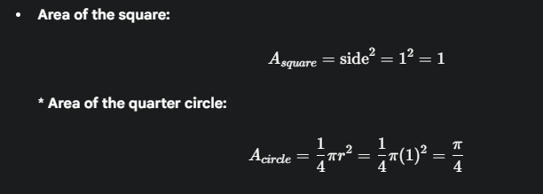
2. The Ratio of Areas The ratio of the area of the quarter circle to the area of the square is:
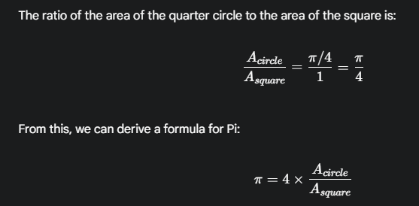
3. The Simulation We can estimate the ratio of the areas by generating a large number of random points within the square and counting how many fall inside the quarter circle.
- Generate a large number, N, of random points (x, y) where both x and y are between 0 and 1.
- For each point, check if it lies inside the quarter circle. A point is inside the circle if its distance from the origin is less than or equal to the radius (1). This is checked using the formula:
x²+y²≤1
.
- Count the number of points that satisfy this condition (M).
- The Estimation 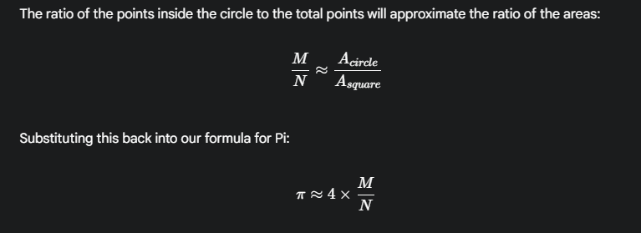
The more points (N) we generate, the more accurate our approximation of Pi becomes.

Sampling of Continuous Distributions
This is the process of generating random numbers that follow a specific continuous probability distribution, such as a Normal, Exponential, or Uniform distribution. This is a foundational technique for building realistic simulations. For example, to simulate customer wait times, you might need to generate random numbers from an Exponential distribution.

- Sampling of continuous distributions:
Sampling of continuous distributions is the process of generating random numbers that follow a specific continuous probability distribution, like the Normal (bell curve) or Exponential distribution.
This technique is essential for creating realistic simulations. For example, to model customer arrival times at a bank, you wouldn't just use any random numbers; you'd generate numbers from an Exponential distribution, as it accurately models the time between random events. Similarly, to simulate natural human characteristics like height, you would sample from a Normal distribution.
A Common Method: Inverse Transform Sampling
One of the most fundamental techniques for this process is the Inverse Transform Sampling method.
The Logic: This method uses the Cumulative Distribution Function (CDF) of the target distribution. The CDF, F(x), gives the probability that a random variable X is less than or equal to a value x. The inverse CDF, F⁻¹(u), does the reverse: for a given probability u, it gives you the corresponding value x.
The Steps:
- Generate a random number u from a standard uniform distribution between 0 and 1.
- Apply this number to the inverse CDF of your target distribution.
- The result, x = F⁻¹(u), is a random number that is a sample from your target distribution.
This process effectively translates a simple uniform random number into a more complex, structured random number that adheres to the statistical properties of the distribution you need to model.

- Monte Carlo methods:
  - Calculate Pi Using Monte Carlo method. (2024) (2023)
Of course. Here is a detailed, step-by-step explanation of how to calculate Pi (π) using the Monte Carlo method, a question featured in both the 2023 and 2024 exam papers.
The Core Concept
The Monte Carlo method uses randomness to solve problems that are otherwise difficult to calculate precisely. To estimate Pi, we use a "hit or miss" approach. Imagine throwing darts randomly at a square board that has a circle drawn inside it. By counting the proportion of darts that land inside the circle versus the total thrown, we can estimate the ratio of the two areas, which allows us to calculate Pi.

Step 1: The Geometric Setup
First, we establish a simple geometric area that involves π.
- Imagine a square on a 2D graph with a side length of 2 units, centered at the origin. Its corners would be at (-1,-1), (1,-1), (1,1), and (-1,1).
- Inscribe a circle inside this square. The circle will also be centered at the origin and will have a radius r = 1.
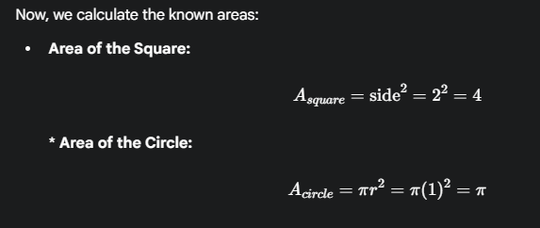
Step 2: The Probabilistic Relationship
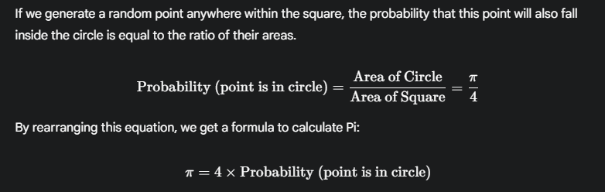
Step 3: The Simulation Procedure
We can approximate the probability by generating thousands of random points and checking where they land.
- Initialize Counters: Start with two counters: points_in_circle = 0 and total_points = 0.
- Generate Random Points: Loop a large number of times (e.g., 1 million times). In each loop:
  - Generate a random point (x, y) by choosing a random x-coordinate between -1 and 1, and a random y-coordinate between -1 and 1. This ensures every point lands inside the square.
  - Increment the total_points counter.
- Check if the Point is in the Circle: For each point, calculate its distance from the origin using the Pythagorean theorem (d = \sqrt{x^2 + y^2}). A point is inside the circle if its distance from the origin is less than or equal to the radius (1). The condition is:
x²+y²≤1
If this condition is true, increment the points_in_circle counter.
- Estimate the Probability: After the loop finishes, the estimated probability is the ratio of the counts:


Step 4: Calculate Pi
Finally, substitute the estimated probability back into our formula from Step 2:

The more points we generate in the simulation, the more accurate our approximation of Pi will become.

2. Hypothesis Testing
- General Steps of Hypothesis Testing:
  - Explain the steps of Hypothesis Testing. (2024) .(2023)
Hypothesis testing is a formal procedure in statistics used to make decisions about a population based on evidence from a sample. It's like a scientific or legal trial for an idea. You start with a default assumption, and then you collect evidence (data) to see if you have enough to challenge that assumption.

Step 1: State the Hypotheses
The first step is to formulate two competing hypotheses.
- Null Hypothesis (H0​):
This is the default assumption, the status quo, or a statement of "no effect." It asserts that any observed difference is due to random chance. It always contains an equality sign (=, ≤, or ≥).
  - Example: The average lifespan of a battery is 50 hours (μ=50).
- Alternative Hypothesis (H1​ or Ha​ ):
This is the claim you are trying to prove. It's the conclusion you accept if you have enough evidence to reject the null hypothesis. It can be one of three types:
  - Two-tailed: Asserts the parameter is simply not equal to the value in the null hypothesis (e.g., μ!=50 ).
  - Left-tailed: Asserts the parameter is less than the value in the null hypothesis (e.g., μ<50 ).
  - Right-tailed: Asserts the parameter is greater than the value in the null hypothesis (e.g., μ>50).

Step 2: Set the Significance Level (α)
The significance level, denoted by alpha (α), is the threshold for our decision. It represents the probability of making a Type I error, which is the error of rejecting a true null hypothesis.
- You choose this value before you collect data. Common choices for α are 0.05 (5%), 0.01 (1%), or 0.10 (10%).
- An α of 0.05 means you are willing to accept a 5% chance of concluding there is an effect when, in reality, there isn't one.

Step 3: Choose the Test and Calculate the Test Statistic
Based on your data and assumptions, you select an appropriate statistical test (e.g., Z-test, T-test, Chi-Square test). Then, you calculate a test statistic.
- A test statistic is a single number that summarizes how far your sample data deviates from the null hypothesis. It measures the difference between your sample statistic and the hypothesized population parameter, standardized by the sample's variability.
- Example Formula (Z-test):
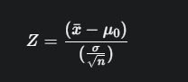
where x̄ is the sample mean, μ₀ is the hypothesized population mean, σ is the population standard deviation, and n is the sample size.

Step 4: Determine the Rejection Rule (Critical Value or p-value)
This step establishes the criteria for your decision. There are two common approaches.
A) The Critical Value Approach
- Based on your significance level (α) and the type of test (one-tailed or two-tailed), you find a critical value from the appropriate statistical distribution (like the Z or T distribution).
- This critical value defines a rejection region. The rejection region is the set of values for the test statistic where you would reject the null hypothesis.
- Rule: If your calculated test statistic falls into this rejection region, you reject H0​
B) The p-value Approach
- The p-value is the probability of observing a test statistic as extreme as, or more extreme than, the one you calculated from your sample, assuming the null hypothesis is true.
- Intuition: A small p-value (e.g., 0.01) means your observed data is very unlikely to have occurred by random chance if the null hypothesis were true.
- Rule: If the p-value is less than or equal to your significance level (p ≤ α), you reject H0​

Step 5: Make a Statistical Decision
Now you apply the rule from the previous step.
- You either compare your test statistic to the critical value or compare your p-value to α.
- This leads to one of two conclusions:
  - Reject the Null Hypothesis: There is enough statistical evidence to support the alternative hypothesis.
  - Fail to Reject the Null Hypothesis: There is not enough statistical evidence to support the alternative hypothesis. (Note: This is different from "accepting" the null hypothesis; it simply means the evidence wasn't strong enough to overturn it).

Step 6: Interpret the Result in Context
The final step is to translate the statistical decision back into a real-world conclusion related to the original problem. You should state your findings in plain language.
- Example: Instead of "We reject the null hypothesis," you would say, "The evidence suggests that the average lifespan of the batteries is significantly greater than 50 hours."

- Type I and II errors:
  - Discuss type 1 and type 2 errors with an example. (2024)
In hypothesis testing, we make decisions about a population based on sample data. Since we aren't testing the entire population, we risk making an incorrect conclusion. There are two specific types of errors we can make: Type I and Type II.
To understand them, let's use a simple analogy: a medical test to diagnose a disease.
- Null Hypothesis (H0​): The patient is healthy.
- Alternative Hypothesis (H1​): The patient has the disease.

Type I Error (False Positive)
A Type I error occurs when you reject the null hypothesis (H0​) when it is actually true.
- Medical Analogy: This is a "false positive." The doctor tells a healthy patient that they have the disease. We have rejected the true null hypothesis ("the patient is healthy").
- Probability: The probability of committing a Type I error is denoted by alpha (α), which is the significance level of the test. When you set α= 0.05, you are accepting a 5% risk of making this type of error.

Type II Error (False Negative)
A Type II error occurs when you fail to reject the null hypothesis (H0​) when it is actually false.
- Medical Analogy: This is a "false negative." The doctor tells a sick patient that they are healthy. We have failed to reject the false null hypothesis ("the patient is healthy").
- Probability: The probability of committing a Type II error is denoted by beta (β). The inverse of this, 1 - β, is the power of the test, which is the probability of correctly identifying a true effect.

Example: A New Drug Trial
Let's consider a more detailed statistical example. A pharmaceutical company is testing a new drug.
- Null Hypothesis (H0​): The new drug has no effect on patient recovery.
- Alternative Hypothesis (H1​): The new drug improves patient recovery.
Here's how the errors would manifest:
- Type I Error (False Positive):
  - The Mistake: The clinical trial concludes that the drug is effective (rejecting H0​), but in reality, it does nothing.
  - The Consequence: A useless and potentially expensive drug with possible side effects is approved for public use. The company and patients waste time and money on an ineffective treatment.
- Type II Error (False Negative):
  - The Mistake: The clinical trial concludes that there is not enough evidence that the drug is effective (failing to reject H0​), but in reality, it works.
  - The Consequence: A potentially life-saving or beneficial drug is abandoned. Society is denied access to an effective treatment. This is a "missed opportunity."
Summary Table
This table summarizes the relationship between your decision and reality.
 | Reality: H₀ is True (Drug has no effect) | Reality: H₀ is False (Drug is effective)
Decision: Reject H₀ (Conclude drug is effective) | Type I Error (α) | Correct Decision (Power)
Decision: Fail to Reject H₀ (Conclude drug has no effect) | Correct Decision | Type II Error (β)
There is always a trade-off between these two errors. Decreasing the chance of one type of error generally increases the chance of the other.

- Rejection regions:
  - Draw a neat diagram of Right-tail, Left-tail and Two sided Z-test and locate Acceptance and rejection regions. (2023)
In hypothesis testing with a Z-test, we use the standard normal (bell curve) distribution to make a decision. The curve is divided into two main areas:
- Rejection Region (Critical Region): This is the area in the tail(s) of the distribution. If your calculated Z-statistic falls in this region, you reject the null hypothesis (H0​). The total area of this region is equal to your chosen significance level, alpha (α).
- Acceptance Region (Fail-to-Reject Region): This is the large central area under the curve. If your Z-statistic falls here, you fail to reject the null hypothesis. Its total area is 1 - α.
- Critical Value: This is the Z-score that acts as a boundary between the acceptance and rejection regions.

Right-Tailed Z-Test
This test is used when the alternative hypothesis (H1) is testing for a "greater than" condition (e.g., μ>50).
- Rejection Region: A single area located in the far right tail of the curve.
- Critical Value: One positive Z-score, denoted as Zα​.
Diagram
The diagram shows a standard normal curve. The shaded area on the far right represents the rejection region. The large unshaded area to the left is the acceptance region.

Left-Tailed Z-Test
This test is used when the alternative hypothesis (H1​) is testing for a "less than" condition (e.g., μ<50).
- Rejection Region: A single area located in the far left tail of the curve.
- Critical Value: One negative Z-score, denoted as −Zα​.
Diagram
The diagram shows a standard normal curve. The shaded area on the far left represents the rejection region. The large unshaded area to the right is the acceptance region.

Two-Sided Z-Test (Two-Tailed)
This test is used when the alternative hypothesis (H1​) is testing for a "not equal to" condition (e.g., μ!=50).
- Rejection Region: The total significance level α is split into two equal parts, with one area in each tail of the curve.
- Critical Values: There are two critical values, one negative (−Z_{α/2}​) and one positive (+Z_{α/2}​).
Diagram
The diagram shows a standard normal curve where the rejection region is composed of two shaded areas, one on the far left and one on the far right. The large unshaded area in the center is the acceptance region.

- Z-test, T-test, F-test:
  - Differentiate between T-Test, Z-Test and F-Test. (2024)
Z-Test
A Z-test is a statistical hypothesis test used to determine if there is a significant difference between a sample mean and a known population mean, or between the means of two samples. It is used under specific, ideal conditions.
- Primary Purpose: To compare means.
- Core Assumption: The defining characteristic of a Z-test is that the population variance (σ2) is known.
- Sample Size: It is used for large sample sizes (typically, n ≥ 30). The large sample size is important because, due to the Central Limit Theorem, the distribution of sample means will be approximately normal, allowing for the use of the Z-distribution.
- Distribution: The test statistic is assumed to follow a Standard Normal Distribution (Z-distribution).
- When to Use: You would use a Z-test in a scenario like this: "A national education board states that the average score on a particular exam is 850 with a standard deviation of 100. A school administrator takes a sample of 50 students from their school to see if their average score is significantly different from the national average." Here, the population standard deviation is known, and the sample size is large.

T-Test
A T-test is also used to compare means, but it is designed for more realistic scenarios where the population variance is not known.
- Primary Purpose: To compare the mean of one or two samples.
- Core Assumption: The defining characteristic is that the population variance (σ2) is unknown. Instead, we use the sample variance (s2) as an estimate.
- Sample Size: It is primarily designed for small sample sizes (typically, n < 30).
- Distribution: The test statistic follows a Student's t-distribution. The t-distribution is similar to the normal distribution but has "heavier tails." This accounts for the extra uncertainty introduced by estimating the population variance from a small sample. As the sample size increases, the t-distribution approaches the normal distribution.
- When to Use: You would use a T-test in a scenario like this: "A researcher wants to test if a new drug lowers blood pressure. They test the drug on a small group of 20 patients and compare their average blood pressure to a control group. The population variance for the drug's effect is unknown."

F-Test
The F-test is fundamentally different because it is not primarily used to compare means in the same way as Z and T-tests. It has two main applications.
- Primary Purpose:
  - To compare the variances of two populations. It tests whether two samples come from populations with equal variances.
  - To compare the means of three or more populations simultaneously. This is its most common use, known as Analysis of Variance (ANOVA). It tests the null hypothesis that all group means are equal against the alternative that at least one group mean is different.
- Core Assumption (for ANOVA): The populations being compared are normally distributed, and they have equal variances (a condition you can check with an F-test itself).
- Distribution: The test statistic follows an F-distribution, which is defined by two sets of degrees of freedom.
- When to Use:
  - Comparing Variances: "A quality control engineer wants to know if the variability in the diameter of ball bearings produced by Machine A is different from that of Machine B."
  - Comparing Means (ANOVA): "A biologist wants to compare the average height of plants grown with three different types of fertilizer to see if there is any significant difference between them."

Detailed Comparison: Z-Test vs. T-Test vs. F-Test
Basis for Comparison | Z-Test | T-Test | F-Test
1. Primary Goal | To test a hypothesis about a population mean. | To test a hypothesis about a population mean. | To compare population variances OR to compare the means of three or more populations (ANOVA).
2. Population Variance (σ2) | Assumed to be known. This is a strict and often unrealistic condition. | Assumed to be unknown. The sample variance is used as an estimate. | Not a precondition. The test either compares variances directly or assumes they are equal (for ANOVA).
3. Sample Size (n) | Used for large samples (typically n ≥ 30), where the sample variance is a reliable estimate of the population variance. | Used for small samples (typically n < 30), where estimating the variance introduces extra uncertainty. | Can be used with various sample sizes, but requires sufficient data per group.
4. Governing Distribution | The test statistic follows the Standard Normal (Z) Distribution. | The test statistic follows the Student's t-distribution, which has heavier tails to account for smaller sample sizes. | The test statistic follows the F-distribution, which is characterized by two sets of degrees of freedom.
5. Number of Groups Compared | Can compare the mean of one or two groups. | Can compare the mean of one or two groups. | Used to compare the means of three or more groups simultaneously (as in ANOVA).
6. Parameter of Interest | The primary parameter of interest is the mean. | The primary parameter of interest is the mean. | The parameter can be variance (comparing two variances) or means (via ANOVA).
7. Test Statistic Formula | 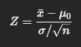 | 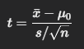 | 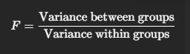
8. Critical Region | Can be one-tailed (left or right) or two-tailed, depending on the hypothesis. | Can be one-tailed (left or right) or two-tailed, depending on the hypothesis. | Is almost always a right-tailed test, as variance ratios cannot be negative.
9. Typical Use Case | Quality control in manufacturing where historical process variance is known. | Medical trials with a small number of participants to test a new treatment's effect. | Agricultural experiments comparing crop yields across multiple different fertilizers.

- Chi-Square test:
The Chi-Square (χ2) test is a statistical hypothesis test used to analyze categorical data. Its main purpose is to determine if there's a significant difference between the observed frequencies (the counts you actually see in your sample data) and the expected frequencies (the counts you would expect if your null hypothesis were true).
There are two primary types of Chi-Square tests:
1. Chi-Square Goodness-of-Fit Test
This test is used to determine if a sample of categorical data comes from a population with a specific, hypothesized distribution. It essentially answers the question: "Does my observed data fit the distribution I expected?"
- Hypotheses:
  - H0​: The observed data fits the expected distribution.
  - H1​: The observed data does not fit the expected distribution.
- Example: A dice manufacturer claims their dice are fair. To test this, you roll a die 120 times. If it's fair, you'd expect each face (1, 2, 3, 4, 5, 6) to appear 20 times. You compare your actual observed counts for each face to these expected counts.
2. Chi-Square Test for Independence
This test is used to determine if there is a significant association or relationship between two categorical variables. It answers the question: "Are these two variables independent of each other?"
- Hypotheses:
  - H0​: The two variables are independent (there is no relationship).
  - H1​: The two variables are dependent (there is a relationship).
- Example: A researcher wants to know if voting preference (Party A, Party B, or Independent) is independent of age group (18-30, 31-50, 51+). They survey a sample of voters and organize the data in a contingency table to see if there's a statistically significant relationship.

The Chi-Square Test Statistic
Both tests use the same formula to calculate the Chi-Square (χ2) statistic:
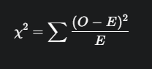
Where:
- O = Observed frequency (the actual count from your data).
- E = Expected frequency (the count you would expect if the null hypothesis were true).
If the observed frequencies are very close to the expected ones, the Chi-Square value will be small. The larger the difference, the larger the Chi-Square value, suggesting that the null hypothesis may be false.

Key Characteristics
- Categorical Data: The test works with frequency counts of categories, not continuous data like height or weight.
- Right-Tailed Test: It's almost always a right-tailed test because we are interested in whether the difference between observed and expected is large. A large difference leads to a large, positive Chi-Square value, which would fall in the right tail of the distribution's rejection region.
- Assumption: The expected frequency for each category should generally be 5 or more for the test to be reliable.

- Bayesian test:
A Bayesian test is an approach to hypothesis testing built on Bayes' Theorem. It differs fundamentally from classical (or frequentist) tests like the Z-test and T-test in its philosophy and output.
Instead of yielding a p-value and a binary "reject" or "fail to reject" decision, a Bayesian test updates our degree of belief in a hypothesis after considering the data.
The Core: Bayes' Theorem
The process revolves around updating our initial beliefs (priors) with the evidence from our data (likelihood) to get a final, updated belief (posterior).
The formula is:

Let's break this down:
- Posterior Probability P(Hypothesis|Data): This is our goal. It's the probability of our hypothesis being true after we've seen the data.
- Likelihood P(Data|Hypothesis): The probability of observing our data if our hypothesis were true.
- Prior Probability P(Hypothesis): The key Bayesian component. This is our belief in the hypothesis before seeing the data. It can be based on previous research or set to be neutral.
- Marginal Likelihood P(Data): The probability of observing the data. It acts as a normalizing constant.
In simple terms: Updated Belief = (Likelihood of data) x (Prior Belief)
Bayesian vs. Classical (Frequentist) Testing
The main difference between the two statistical philosophies is in the fundamental question they answer.
- Classical Test: Asks, "Assuming the null hypothesis is true, what is the probability of seeing this data?" (This gives a p-value).
- Bayesian Test: Asks, "Given the data I've seen, what is the probability that my hypothesis is true?" (This gives a posterior probability).

Detailed Comparison
Feature | Classical Testing (e.g., Z-test, T-test) | Bayesian Testing
Primary Output | A p-value and a binary decision (reject / fail to reject H0​ ). | A posterior probability for one or more hypotheses. | .
Use of Prior Information | Does not formally use prior knowledge or beliefs. | Formally incorporates a prior probability into the model.
Interpretation | Gives the probability of the data, assuming H0​ is true. It does not give the probability of being true. | Directly gives the probability of the hypothesis being true, given the data, which is often more intuitive |  | ​ |  |  | .

Example: Testing a New Website Design
Scenario: You want to test if a new website design (Design B) has a higher conversion rate than the old design (Design A).
Hypotheses:
- H1​ (Alternative): Design B's conversion rate is higher.
- H0​ (Null): Design B's conversion rate is not higher.
The Bayesian Approach:
- Set Priors: Before the test, you state your initial beliefs. For example, you might believe there's a 50% chance that Design B is better (P(H1​) = 0.5) and a 50% chance it isn't (P(H0​) = 0.5).
- Collect Data: You run an A/B test, showing both designs to users and collecting conversion data.
- Calculate Likelihood: You determine how likely your observed data is under each hypothesis.
- Calculate Posterior: Using Bayes' theorem, you update your initial 50/50 belief with the evidence from the data. The result might be a statement like: "There is now a 95% probability that Design B has a higher conversion rate."
Instead of a simple "reject/fail to reject" decision, the Bayesian approach provides a direct statement of confidence in your hypothesis.

3. Stochastic Processes and Data Modeling
- General Stochastic Processes:
  - Explain Stochastic Processes with the help of an Example. (2024)
A stochastic process is a mathematical model for a system that evolves over time in a random or probabilistic manner. Think of it as a "movie" made up of random events. A single snapshot in time gives you a random variable, but the entire process describes how that variable changes randomly over time.
It's defined by two key components:
- State Space: The set of all possible values the system can take.
- Index Parameter (Time): The sequence of time points at which the system is observed. This can be discrete (e.g., every day) or continuous (at every instant).

Example: A Simple Random Walk
The "random walk" is a classic example of a stochastic process that's easy to understand.
Scenario: Imagine a person standing on a number line at position 0. Every second, they flip a fair coin:
- If it's Heads, they take one step to the right (+1).
- If it's Tails, they take one step to the left (-1).
This is a stochastic process because:
- It evolves over time: The person's position changes every second. This is a discrete-time process.
- It's random: The future position is not predetermined; it depends on the random outcomes of the coin flips.
- The Random Variable: The person's position on the number line at any given time t is the random variable, X(t).
- The State Space: The set of all possible positions is all the integers (..., -2, -1, 0, 1, 2, ...).
After 3 seconds, one possible path (Heads, Tails, Heads) could look like this:
- t=0: Position = 0
- t=1: Position = 1 (Heads)
- t=2: Position = 0 (Tails)
- t=3: Position = 1 (Heads)
We cannot predict the exact path, but we can use the stochastic process model to answer questions like, "What is the probability that the person will be at position 5 after 10 steps?"

Other Real-World Examples
- Finance: The daily closing price of a stock.
- Queuing Theory: The number of customers arriving in a queue over time (a Poisson Process).
- Biology: The random movement of a particle in a fluid (Brownian Motion).
- Weather: The daily change in weather conditions (e.g., from Sunny to Rainy), which can be modeled as a Markov Chain.

- Markov process:
A Markov process is a type of stochastic process that models systems evolving over time. Its defining characteristic is the Markov Property, which makes it a powerful tool for analyzing random sequences.
The Markov Property (The "Memoryless" Property)
The Markov property states that the future state of the system depends only on its present state, not on the sequence of events that preceded it. The past is irrelevant given the present.
- Analogy: A Chess Game ♟️ The next possible moves for a chess piece depend only on its current position on the board. It doesn't matter how the piece arrived at that square; its history is irrelevant for determining its future possibilities.
This "memoryless" nature simplifies the modeling of complex systems.
Components of a Markov Process
A simple Markov process (often called a Markov Chain) has two main components:
- States: A finite set of possible conditions the system can be in.
- Transition Probabilities: The probability of moving from one state to another. These are often organized into a Transition Matrix, where each row represents the current state and each column represents the next state. The probabilities in each row must sum to 1.

Example: A Simple Weather Model
Let's model the weather in a city, which can only be in one of two states: Sunny or Rainy. ☀️🌧️
- States: {Sunny, Rainy}
- Markov Assumption: The weather tomorrow depends only on the weather today.
Transition Probabilities: Let's define the probabilities of moving between states:
- If it's Sunny today, the probability it's Sunny again tomorrow is 0.9.
- If it's Sunny today, the probability it's Rainy tomorrow is 0.1.
- If it's Rainy today, the probability it's Rainy again tomorrow is 0.5.
- If it's Rainy today, the probability it's Sunny tomorrow is 0.5.
Transition Matrix: We can represent this in a matrix P:
 | (Next) Sunny | (Next) Rainy
(Current) Sunny | 0.9 | 0.1
(Current) Rainy | 0.5 | 0.5
State Diagram: This process can be visualized with a state diagram where the nodes are states and the arrows are the transition probabilities.
Using this model, we can predict the likelihood of future weather patterns based only on the current day's weather.

- Hidden Markov Models (HMM):
  - Explain Transition State Diagram and Emission State Diagram of Hidden Markov Model with the help of example. (2024) (2023)
A Hidden Markov Model (HMM) is a statistical model where the system being modeled is assumed to be a Markov process with unobservable or hidden states. We can only infer the sequence of hidden states by observing a sequence of related emissions.
To explain the two main diagrams, let's use a simple example.
- Example Scenario: You have a friend whose mood you cannot directly see, but you can observe the activity they choose to do each day.
  - Hidden States: The friend's mood: {Happy, Grumpy}.
  - Observable Emissions: The activity they perform: {Read, Shop, Clean}.

Transition State Diagram
The Transition State Diagram describes the "hidden" part of the model. It shows the probability of moving from one hidden state to another. This is essentially a standard Markov Chain diagram.
- What it shows: The likelihood of the friend's mood changing from one day to the next.
- Example Probabilities:
  - If the friend is Happy today, there's an 80% chance they'll be Happy tomorrow.
  - If the friend is Happy today, there's a 20% chance they'll be Grumpy tomorrow.
  - If the friend is Grumpy today, there's a 40% chance they'll be Happy tomorrow.
  - If the friend is Grumpy today, there's a 60% chance they'll be Grumpy tomorrow.
Diagram: This diagram shows the two hidden states (Happy, Grumpy) and the probabilities of transitioning between them.

Emission State Diagram
The Emission State Diagram describes the connection between the hidden states and the observable emissions. It shows the probability of observing a particular emission given that the system is in a specific hidden state.
- What it shows: How likely the friend is to perform a certain activity based on their current (hidden) mood.
- Example Probabilities:
  - When Happy: P(Shop) = 0.6, P(Clean) = 0.3, P(Read) = 0.1
  - When Grumpy: P(Shop) = 0.1, P(Clean) = 0.4, P(Read) = 0.5
Diagram: This diagram shows how each hidden state "emits" the observable activities with certain probabilities.
In summary, the Transition Diagram models how the system changes internally (friend's mood), while the Emission Diagram models what we can see as a result of that internal state (friend's activity).

- Poisson Process:
  - Define Poisson process. Poisson process is a suitable stochastic model in rare events. Justify?. (2023)
A Poisson process is a type of stochastic process that is used to count the number of times an event occurs within a fixed interval of time or space. The process is defined by a single parameter, lambda (λ), which represents the average rate at which events occur. For example, it could model the number of emails arriving in your inbox per hour.

Justification for Modeling Rare Events
A Poisson process is an excellent model for "rare events." In this context, "rare" does not mean the event hardly ever happens; rather, it means that for any infinitesimally small interval of time, the probability of more than one event occurring is practically zero.
The suitability of the Poisson process for such events is justified by its three core properties:
- Independence: Events occur independently of one another. The number of events in any time interval is independent of the number of events in any other non-overlapping interval.
  - Justification: For rare events like radioactive decay, the decay of one atom does not influence when the next one will decay. They are independent occurrences.
- Constant Average Rate (λ): The probability of an event occurring in an interval is proportional to the length of that interval. This means the average rate of events is constant over time.
  - Justification: While rare events are random, they can often be averaged over a long period to get a stable rate. For example, we can talk about the average number of major earthquakes per decade or the average number of typos a professional typist makes per page.
- No Simultaneous Events: The probability of two or more events occurring at the exact same instant is negligible (it approaches zero).
  - Justification: This is the core of the "rare event" argument. It is impossible for two phone calls to arrive at a call center at the exact same microsecond. Each event is a distinct, separate point in time. This property ensures that we are counting discrete, non-overlapping events.
Because a Poisson process assumes that events are independent, happen at a constant average rate, and don't occur simultaneously, it perfectly describes the behavior of many phenomena that we consider to be collections of rare, random events.

Examples of Rare Events Modeled by a Poisson Process
- The number of phone calls arriving at a call center per hour. (Each call is independent and they don't arrive at the exact same millisecond).
- The number of major accidents at a particular intersection per year.
- The number of misprints on a page of a book.
- The number of radioactive particles decaying in a sample per minute.

- Queuing Systems (Application of Stochastic Processes):
  - How does a queuing system work? What happens with a job when it goes through a queuing system?. (2023)
A queuing system is a mathematical model used to study waiting lines, or queues. It analyzes how "jobs" arrive, how long they wait, and how they are served. These systems are applications of stochastic processes because key events, like the arrival of jobs and the time it takes to serve them, are random. A common real-world example is the checkout line at a supermarket. 🛒

How a Queuing System Works: The Components
A basic queuing system is defined by three main components:
1. The Arrival Process This describes how jobs (e.g., customers, data packets, cars at a toll booth) enter the system.
- The arrivals are typically modeled by a Poisson process, meaning the time between arrivals is random and follows an exponential distribution.
- The key parameter is the arrival rate (λ), which is the average number of jobs arriving per unit of time.
2. The Queue (Waiting Line) This is where jobs wait if the server is busy. The queue is defined by:
- Queue Discipline: The rule used to select the next job for service. The most common is First-In, First-Out (FIFO), where the first to arrive is the first to be served.
- Capacity: The maximum number of jobs the queue can hold. It can be infinite or finite.
3. The Service Facility (Server) This is where the job is processed. There can be one or more servers.
- Service Time: The amount of time it takes to process one job. This is also a random variable, often modeled by an exponential distribution.
- The key parameter is the service rate (μ), which is the average number of jobs a server can complete per unit of time.

The Journey of a Job
Here is what happens to a single job as it moves through a standard queuing system:
- Arrival: A job arrives at the system at a random point in time.
- Assessment: Upon arrival, the job checks the status of the server(s).
  - If a server is free, the job bypasses the queue and goes directly into service.
  - If all servers are busy, the job must enter the waiting line.
- Waiting: The job waits in the queue, following the queue discipline (e.g., FIFO). It remains in this waiting state until a server becomes available and it is selected.
- Service: When the job reaches the front of the line and a server is free, it moves from the queue to the service facility. The service process begins and takes a random amount of time to complete.
- Departure: Once its service is finished, the job leaves the system. The server is now free to take the next job from the queue.

- Gaussian Processes:
A Gaussian Process (GP) is a powerful tool in machine learning and statistics used for modeling data. Instead of assuming data fits a specific line or curve (like in linear regression), a GP models the data by defining a probability distribution over all possible functions that could fit the data.
Think of it this way:
- A Normal Distribution describes the probability of a single random variable (a single number).
- A Multivariate Normal Distribution describes the probability of a finite set of random variables (a vector).
- A Gaussian Process extends this to an infinite set of random variables, representing a distribution over entire functions.
Key Components of a Gaussian Process
A GP is completely defined by two components:
- Mean Function m(x): This represents the average or expected value of the function at any point x. It's our initial guess for the function's shape before we see any data. Often, this is simply set to zero.
- Covariance Function (or Kernel) k(x, x'): This is the most important part. The kernel defines the "smoothness" and shape of the functions. It calculates the similarity (covariance) between the function's values at two different points, x and x'. A common kernel will state that if x and x' are close together, their corresponding function values f(x) and f(x') should be highly correlated.
Application: Gaussian Process Regression (GPR)
The most common use of GPs is for regression. GPR is a non-parametric, Bayesian approach to modeling.
How it Works:
- Define a Prior: We start by defining a GP (using a mean and kernel) that represents our prior belief about the possible functions. This is like a vast "cloud" of potential functions.
- Observe Data: We are given a set of training data points.
- Condition on Data: The model then uses Bayes' theorem to discard all functions from the prior "cloud" that are not consistent with the observed data points.
- Get a Posterior: The result is a posterior distribution over functions. This is a new, more refined cloud of functions that all fit the data we've seen.
The Output: The key advantage of GPR is that for any new input point, it doesn't just give a single prediction; it gives:
- A mean prediction: The most likely value.
- A variance (or confidence interval): A measure of uncertainty about the prediction. The model is "sure" about its predictions near the data it has seen and becomes "less sure" further away.
The image illustrates how the initial cloud of possible functions (prior) is refined by the data points, resulting in a specific prediction curve (the posterior mean) with a shaded confidence interval that grows larger in areas with no data.

- Auto-Regressive and Moving average processes:
Auto-Regressive (AR) and Moving Average (MA) models are fundamental concepts in time series analysis. They are used to understand and predict future values in a series by looking at its own past data.

Auto-Regressive (AR) Process
An AR process is one where the current value of a time series is modeled as a linear combination of its own past values, plus a random error term. The name "auto-regressive" means "regressing on itself."
- Core Idea: The present is a function of the past. Today's stock price is likely related to yesterday's price.
- Formula for an AR(p) model:
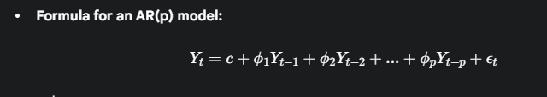
- Yt​ is the current value.
  - Yt−1​,...,Yt−p​ are the past values.
  - p is the order of the model, indicating how many past values are included.
  - ϕ1​,...,ϕp​ are the model coefficients.
  - ϵt​ is the random error (white noise) at the current time.
- Use Case: AR models are good at capturing momentum and trend-following behavior in a time series.

Moving Average (MA) Process
An MA process is one where the current value of a time series is modeled as a linear combination of the past random error terms. It does not use past values of the series itself.
- Core Idea: The present is a function of past prediction errors or "shocks." Today's stock price might be affected by the unexpected news (a random shock or error) from yesterday.
- Formula for an MA(q) model:
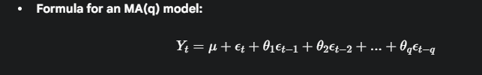
- Yt​ is the current value.
  - μ is the mean of the series.
  - ϵt−1​,...,ϵt−q​ are the past error terms.
  - q is the order of the model.
  - θ1​,...,θq​ are the model coefficients.
- Use Case: MA models are good at capturing short-run shock effects that are quickly corrected.

Combining the Models: ARMA & ARIMA
In practice, a time series often exhibits characteristics of both processes. Therefore, they are often combined:
- ARMA (Auto-Regressive Moving Average): An ARMA(p,q) model combines both AR and MA components to model both past values and past errors.
- ARIMA (Auto-Regressive Integrated Moving Average): An ARIMA(p,d,q) model extends ARMA to handle non-stationary time series (where the mean or variance changes over time). The "I" for Integrated (d) refers to the number of times the data has been differenced to make it stationary.

- Bayesian Network:
A Bayesian Network is a type of probabilistic graphical model that represents the relationships and conditional dependencies between a set of random variables. It uses a Directed Acyclic Graph (DAG) to model a complex system in an uncertain world.
The core idea is to show how different variables influence each other.
Components of a Bayesian Network
- Nodes: Each node in the graph represents a random variable. This could be a discrete variable (e.g., Rain: {Yes, No}) or a continuous one.
- Directed Edges (Arrows): An arrow from Node A to Node B signifies that Node A has a direct causal influence on Node B. The graph must be acyclic, meaning you cannot follow the arrows in a loop back to the starting node.
- Conditional Probability Table (CPT): Each node has a CPT that quantifies the effect of its parents. It specifies the probability of that node being in a particular state, given the states of all its parent nodes.

Example: The "Wet Grass" Problem
This is a classic example used to explain Bayesian Networks. 🧠
Scenario: You wake up and notice your grass is wet. You want to figure out why. There are two possible direct causes: it rained, or the sprinkler was on. The chance of rain is influenced by whether it's a cloudy day.
The Model:
- Nodes (Variables): Cloudy, Sprinkler, Rain, Wet Grass.
- Edges (Relationships):
  - An arrow from Cloudy to Rain (clouds cause rain).
  - An arrow from Cloudy to Sprinkler (you're less likely to use the sprinkler if it's cloudy).
  - Arrows from Rain and Sprinkler to Wet Grass (both can make the grass wet).
The Graph (DAG):
The Probabilities (CPTs): Each node has a CPT.
- Cloudy has a simple prior probability: P(Cloudy = True) = 0.5.
- Rain has a CPT dependent on Cloudy: P(Rain=T | Cloudy=T) = 0.8.
- Sprinkler has a CPT dependent on Cloudy: P(Sprinkler=T | Cloudy=T) = 0.1.
- Wet Grass has a CPT dependent on both Rain and Sprinkler: P(WetGrass=T | Rain=T, Sprinkler=F) = 0.9.
How It's Used (Inference): The power of a Bayesian Network is its ability to reason with uncertainty.
- If you observe that the grass is wet, you can use the network to calculate the updated (posterior) probability that the cause was rain.
- If you then observe that the sprinkler was off, the network will update again, and the probability that it rained will increase significantly. This is called probabilistic inference.

- Regression:
Regression analysis is a powerful statistical method used to model the relationship between a dependent variable and one or more independent variables. The main goal is to understand how the dependent variable changes when one of the independent variables is varied, and it's widely used for prediction and forecasting.
The key components are:
- Dependent Variable (Y): The outcome you are trying to predict (e.g., salary).
- Independent Variable(s) (X): The factors used to predict the outcome (e.g., years of experience).

Simple Linear Regression
This is the most basic form of regression, used when you have one independent variable (X) to predict a dependent variable (Y). It aims to find the best-fit straight line that describes the relationship.
Formula:

- Y: The dependent variable (what you're predicting).
- X: The independent variable (the predictor).
- β0​: The intercept. It's the value of Y when X is 0.
- β1​: The slope or coefficient. It represents the change in Y for a one-unit increase in X.
- ϵ: The error term, representing the part of Y that the model cannot explain.
Example: Predicting a person's salary based on their years of experience.
- Y: Salary
- X: Years of Experience

Multiple Linear Regression
This is an extension used when you have two or more independent variables influencing the dependent variable.
Formula:
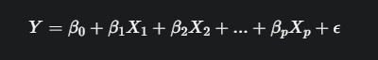
- Each independent variable (X1​,X2​, etc.) has its own coefficient (β1​,β2​, etc.) that quantifies its effect on Y while holding other variables constant.
Example: Predicting a person's salary based on multiple factors.
- Y: Salary
- X1​: Years of Experience
- X2​: Level of Education (e.g., encoded numerically)
- X3​: City of Residence (e.g., encoded as a categorical variable)

How it Works: Ordinary Least Squares (OLS)
The most common method to find the "best-fit" line is Ordinary Least Squares (OLS). Its goal is to find the values for the coefficients (β0​,β1​, etc.) that minimize the sum of the squared residuals. A residual is simply the vertical distance between an actual data point and the regression line—in other words, the prediction error for that point.

